Introduction to Bash

1) Write a simple Bash shell script to display the message "Welcome to Bash learning" and "\*\*\*\*\*\*\*\*\*\*\*\*\*\*\*" on separate lines.

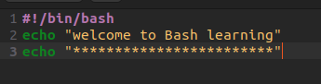

TERMINAL

